Rules of the Game:
- To begin, pieces are arranged on a 7x7 grid as shown. The center piece is the king.

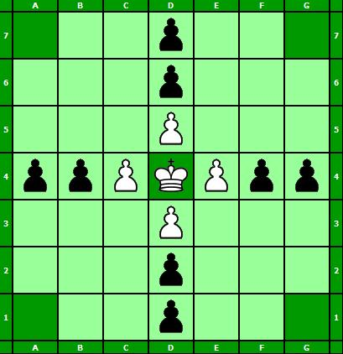

- Each piece can move in any cardinal direction, as far as it wants until it runs into another piece. The exceptions are the corners and the center, which only the king can land on. However, other pieces can pass through the center tile, called the throne.
- Pieces on one team can capture and remove from play the other team’s pieces by surrounding them on opposite sides. There are some exceptions to this:
  - If the king is on the throne, it must be surrounded on all four sides to be captured.
  - If the king is next to the throne, it must be surrounded on the other three sides.
  - The corner tiles are considered hostile and can help either team capture the other’s pieces.
- Black needs to capture the king to win. White wins by getting the king into one of the four corners and thereby preventing this.
http://www.dragonheelslair.com/en/rulesbrandubh.php

